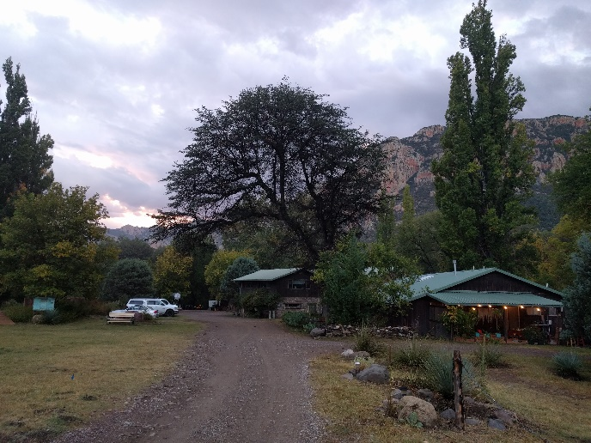
Trees of the Chiricahua Mountains—Biology, Ecology and Drought Adaptations.
A meeting of arborists, naturalists, and biologists to study trees and their adaptations in the Chiricahua Mountains of South East Arizona
October 7-11, 2019.
Dr. James Downer University of California Cooperative Extension: ajdowner@ucdavis.edu

Dr. Ursula Schuch University of Arizona: uschuch@email.arizona.edu

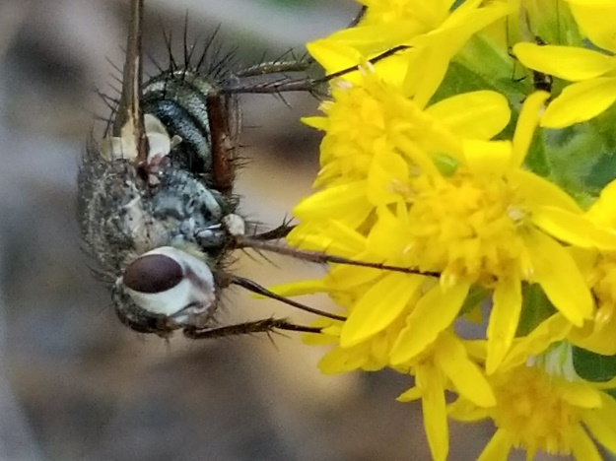
Purpose: The sky islands are a group of mountain ranges in Southeastern Arizona that are isolated from each other by desert lowland scrub and grassland plant communities. The unique warm and wet climate, relative isolation of these ranges, their unique geological history, and the alternating dry and wet patterns stimulate the development of biodiversity hot spots. The Chiricahua Mountain range is the largest of the sky islands and is the home of the South Western Research Station (SWRS). Trees in these mountains are adapted to hot and dry climates and to heavy summer rain as well as occasional winter rain. These qualities make them ideal for study as candidates for cultivation in arid landscapes. The Chiricahuas also offer us a laboratory to examine tree adaptations and natural history up close. The high species diversity, unique landforms, soils, abundance of insects and animals, and sheer beauty of this part of South Eastern Arizona are unlike anything else in the world.
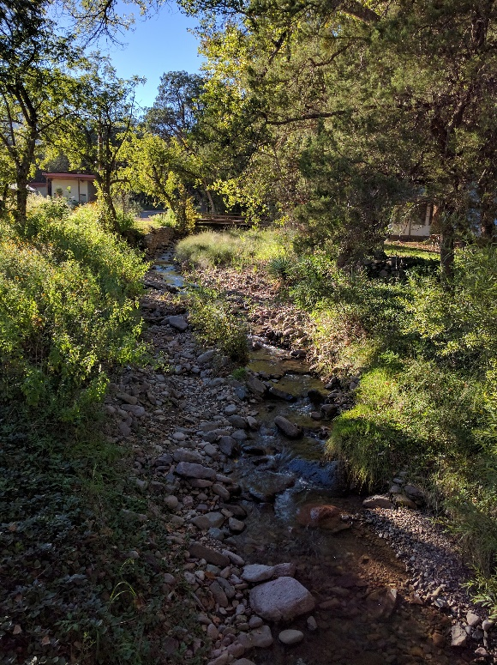
Registration: Registration includes all meals and lodging (dormitory style),book, seminars, and field trips for five days. The Meeting is held at the SWRS of the American Museum of Natural History, Portal, AZ. More information about SWRS can be found on their web page at: https://www.amnh.org/our-research/southwestern-research-station. The cost for full registration is $130.00 per day or $680 for the five days. Additional nights can be arranged with the station if you wish to extend your stay with early arrival or late departure. The nearest airport is in Tucson approx. 3 hours drive from the west. We will attempt to coordinate shared rides if enough people require pick up. From California, Los Angeles area, plan for a 10-12 hour drive. Local attendees can participate in the full program including meals but excluding lodging for $325. There is a slight cost difference for Sunday vs Monday arrivals. To reserve your spot in the course please contact Alina or Karen at SWRS (520-558-2396) and mail a check made to: Southwestern Research Station, P.O. Box 16553, Portal, AZ 85632.
20 International Society of Arboriculture continuing education credits have been applied for.

Sunday: Early Arrival Day--check in at office for room assignment, Dinner
Monday Arrival Day
7:30am Breakfast/registration/arrival and check in during this period.. Relax you are at the station!
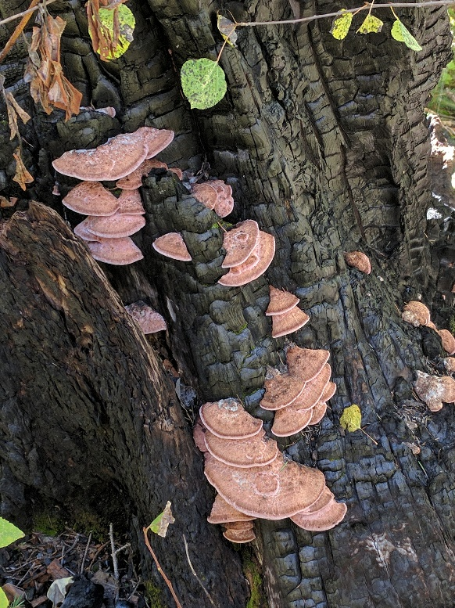
12:00pm Lunch
1:00pm Species diversity in the Chiricahua Mountains. Dr. Howard Topoff and Dr. Carol Simon, Portal, AZ
2:00pm -SWRS a brief history --what is here: station guidelines, boundaries, hikes and trails. Alina Downer
3:00pm Exploring the station grounds, creek drainages, canyons, and riparian woodlands. David B. Kelley, Kelley and Associates Environmental Sciences Inc. and Alina, Jim Downer
4:00-Free Time
6pm Dinner
-7pm Seminar: Soils and landforms of the Chiricahua Mountains David B. Kelley, Kelley and Associates Environmental Sciences Inc.
Tuesday
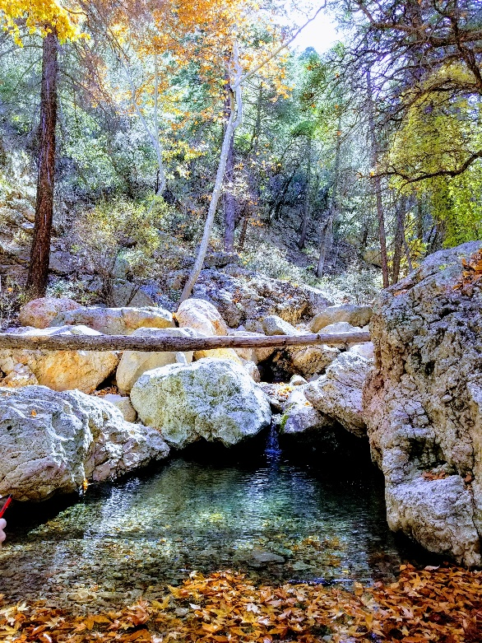
7:30am Breakfast
8:30 Morning Seminar: Insects, Ants and other arthropods associated with Trees in the Chiricahua Mountains. Dr. Michelle Lanan, Resident Research Scientist, SWRS
10:00 am Mid-Morning Seminar: The geology of the sky islands its effects on plants. Ms. Sonia Norman, The Desert Museum, Tucson, AZ
12:00 Lunch
1:00pm Field Trip to the South Fork of Cave Creek. Trees of South Fork. 5 mile hike in a creek canyon. Easy walking.
4:00pm return from South Fork and Free Time
6:00pm Dinner
7:00pm Evening Seminars: Drought Adaptation Strategies For Trees In The Chiricahua Mountains Dr. Ursula Schuch, University of Arizona
8:00 pm Fungi of the Chiricahua Mountains and their relationship to trees.
Dr. James Downer, University of California, Ventura County

Wednesday
7:30am Breakfast
8:30am Depart for Granite Gap Field Trip. This is an exploration of the granite gap area 2 miles of walking about to examine tree adaptations. Hilly terrain some climbing and rock scrambling.
9:00-11:15 Hike at granite Gap: Trees In A Desert Environment: Drought Survival And Monsoon Restoration.
11:15- noon Travel back to SWRS
12:00pm Lunch
1:00 pm Dendrochronology workshop and how to use an increment borer to evaluate annular growth increments. What does this mean in a location with a monsoon climate system?
Dr. Kevin T. Smith, US Forest Service
3:00pm Pathogens of the woody support systems of trees. Dr. Kevin Smith, US Forest Service
6:00pm Dinner
7:00pm Evening Seminar The Ecology Of Cavity Nesting Birds In Cave Creek Arizona (Dave Oleyar, Hawkwatch international
8:00pm Night walk with Dave and Owl watching.
Thursday
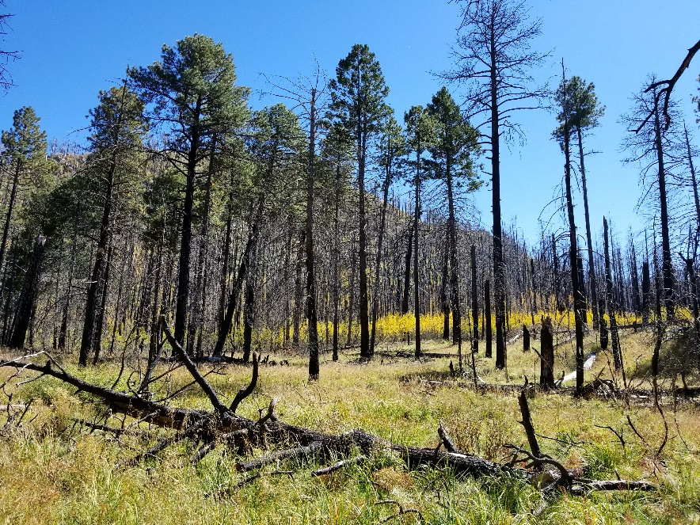
7:30 Breakfast (pack lunches)
8:30 am Morning Seminar: Fire And Post Fire Adaptation Of Trees In Cochise County. Dr. James Malusa, University of Arizona
9:30 am Caravan to Barfoot Park This is a short hike with elevation 7000-8500 feet here.
10:00 am Conifer Biology in Barfoot Park. Aspen and Conifer regeneration post fire. Smith, Malusa
12:00 Lunch at Rustler Park.
Fungi of conifers (fungal fore) Dr. Kevin Smith and James Downer.
Conifer identification, Dr. Malusa
4:00 pm return to SWRS and Free Time
6:00pm Dinner
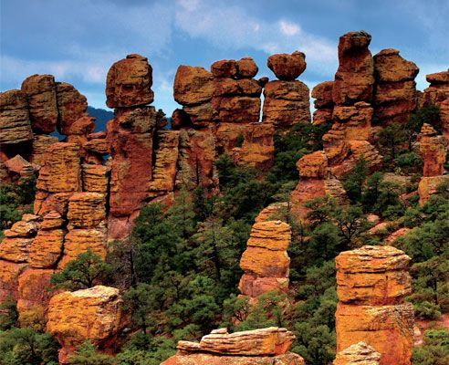
7:00 Seminar: Oaks of the Sierra Madre Occidentale Mr. Adam Black, Director of Horticulture, Peckerwood Gardens, Tx
8:00 -9:00 Owl walk with Dr. Dave Oleyar, Hawkwatch International

Friday
7:30 Breakfast
8:30 depart for Chiricahua Monument
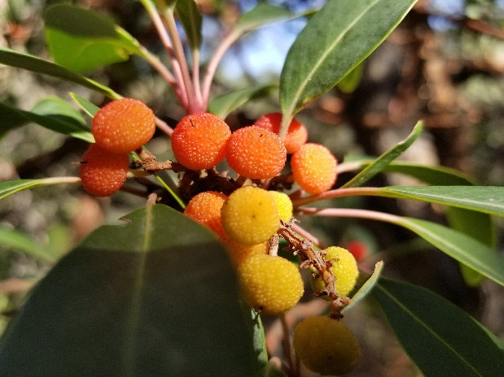
Landforms in the Monument, Geology and Tree adaptations: Norman, Malusa, Kelley
12:00 Lunch at the monument
1:00pm Tour the wonderland of rocks and note and study trees of the Chiricahua Monument. This is a several mile hike inside the monument but mostly down hill.
6:00 pm Dinner SWRS
7:00pm Closing Seminar: Trees Of The Chiricahua Mountains And The Potential For their Horticultural Selection For Landscape uses. Dr. James Downer, University of California
Saturday
7:30 Breakfast and departure.

