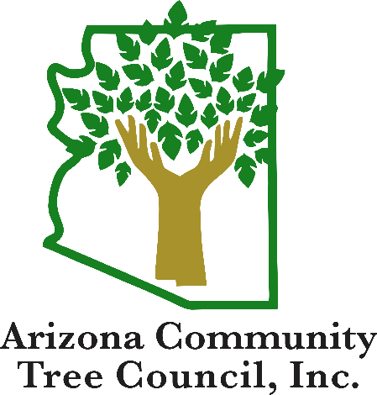
Arizona Community Tree Council presents
Tree Pruning Workshop * Taller de Poda de Árboles
2 classes at same time / 2 separate rooms
Class # 1 - Presented in English ONLY
Class # 2 - Presented in Spanish ONLY
Thursday, October 22, 2020
Yuma Civic Center, 1440 W Desert Hills Dr, Yuma, AZ 85365

Schedule Session

6:00 – 6:30am Registration

6:30 am - 7:30 am Tree Growth and Development

7:30 am - 8:30 am Proper Planting and Pruning Methods

8:30 am - 9:30 am Safely Working Around Trees

9:30 am - 10:30 am Utility Hazard Awareness

